

Submitted to: Bilal Sir

Submitted by: Yash Patel

Date: 27 February 2025

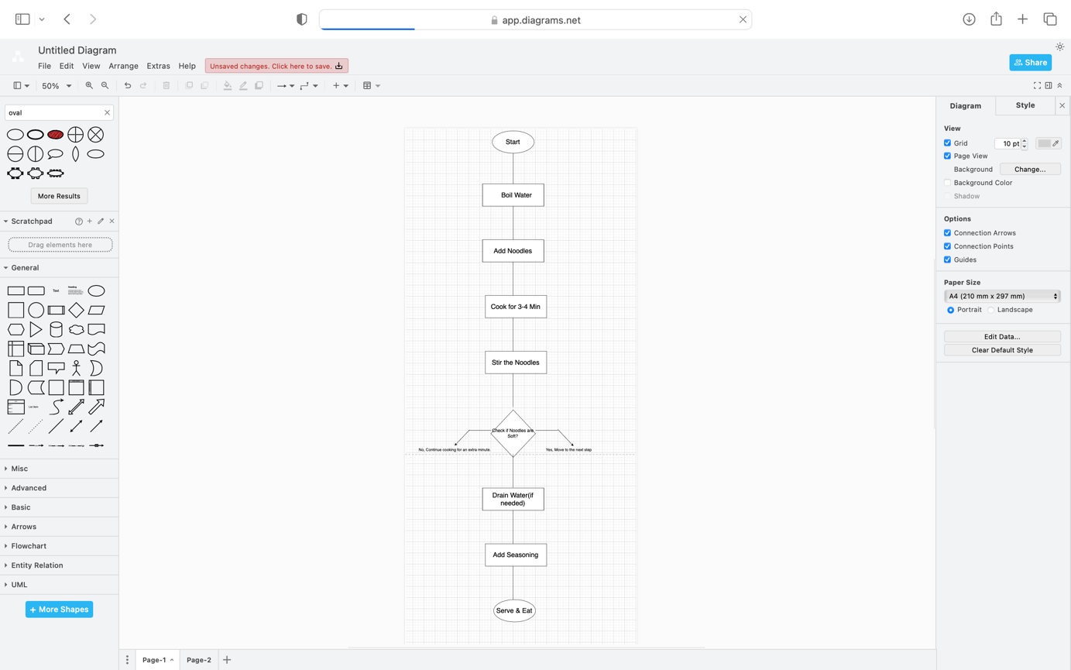

pseudocode:  
  
  
Start

First, boil some water in a pot.

Once the water is boiling, add the noodles.

Let the noodles cook for about 2-3 minutes.

Stir the noodles now and then to keep them from sticking.

While the noodles aren't soft yet:

Keep cooking them.

Stir them regularly.

Once the noodles are soft, drain the water (if necessary).

Pick your favorite seasoning and sauce to add.

Serve the noodles and enjoy your meal!

End